1. Write a PHP script using nested for loop.

Program:

Input:

<?php

$n=5;

for($i=1; $i<=$n;$i++){

   for($j=1;$j<=$i;$j++){

      echo "*";

   }

   echo "<br>";

}

for($i=$n; $i>=1;$i--){

   for($j=1;$j<=$i;$j++){

      echo "*";

   }

   echo "<br>";

}

?>

Output:



1. Write a PHP program to generate and display the first n lines of a Floyd.

Program:

Input:

<?php

// Declaring number of lines we need in a triangle

$n = 5;

echo "n = " . $n . "<br>";

//Specifying from where we need to print

$count = 1;

for ($i = $n; $i > 0; $i--)

{

for ($j = $i; $j < $n + 1; $j++)

{

echo " ".$count." ";

$count++;

}

echo "<br>";

}

?>

Output:

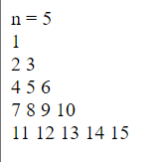

1. Write a PHP script to calculate and display average temperature, five lowest and highest temperatures in given data.

Program:

Input:

<?php

$temperatures = array(78, 60, 62, 68, 71, 68, 73, 85, 66, 64, 76, 63, 75, 76, 73, 68, 62, 73, 72, 65, 74,

62, 62, 65, 64, 68, 73, 75, 79, 73);

min($temperatures);

max($temperatures);

count($temperatures);

array_sum($temperatures);

print "Min value of temperature is: ".$a= min($temperatures);

echo "<br>";

print "Max value of temperature is: ".$b= max($temperatures);

echo "<br>";

print "Count of temperature is: ".$c= count($temperatures);

echo "<br>";

print "Sum of temperature: ".$d= array_sum($temperatures);

echo "<br>";

$avg=$d/$c;

echo "The Avrage of Temperature is: ".$avg. ".<br>";

echo "List of five lowest temperatures : ";

for($i=0; $i<5; $i++)

{

    sort($temperatures);

echo " $temperatures[$i] ";

}

echo "<br>";

echo "List of five highest temperatures : ";

for($i = $c-5; $i <= $c-1; $i++)

{

echo "$temperatures[$i], ";

}

?>

Output:

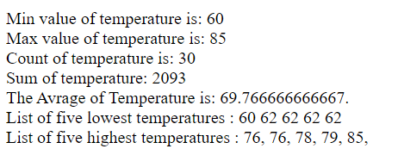

1. Write a simple PHP class which displays the given string.

## Program:

Input:

<?php

echo "Hello This is Your World<br>";

echo "How are you";

?>

Output:

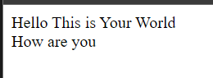

1. Write a PHP function that checks whether a passed string is a palindrome or not?

Program:

Input:

<?php

function palindrome(){

      $num=546456;

      $rev= strrev($num);

   if($num==$rev){

      echo "$num is a Palindrome.";

   }else{

      echo "$num is not a Palindrome.";

   }

   }palindrome();

?>

Output:



1. Write a function to check a number is prime or not.

Program:

Input:

<?php

 echo "<h3>Check whether the given number is prime or not</h3>";

            $a=70;

            for($i=2; $i<$a; $i++){

                if($a % $i == 0){

                    echo "$a is not a Prime Number";

                }else{

                    echo "$a is a Prime Number";

                }

                break;

            };

?>

Output:

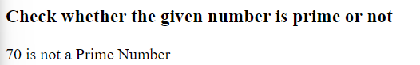

1. Write a program to calculate and print the factorial of a number using a for loop.

Program:

Input:

<?php

function factNum(){

        $num = 10;

        $factorial = 1;

        for ($i = 1; $i <= $num; $i++) {

            $factorial *= $i;

            }

            echo "The factorial of $num is $factorial";

       }

       factNum();

?>

Output:

